Hart Publishing is very pleased to announce the publication of Anticipatory Breach by Qiao Liu

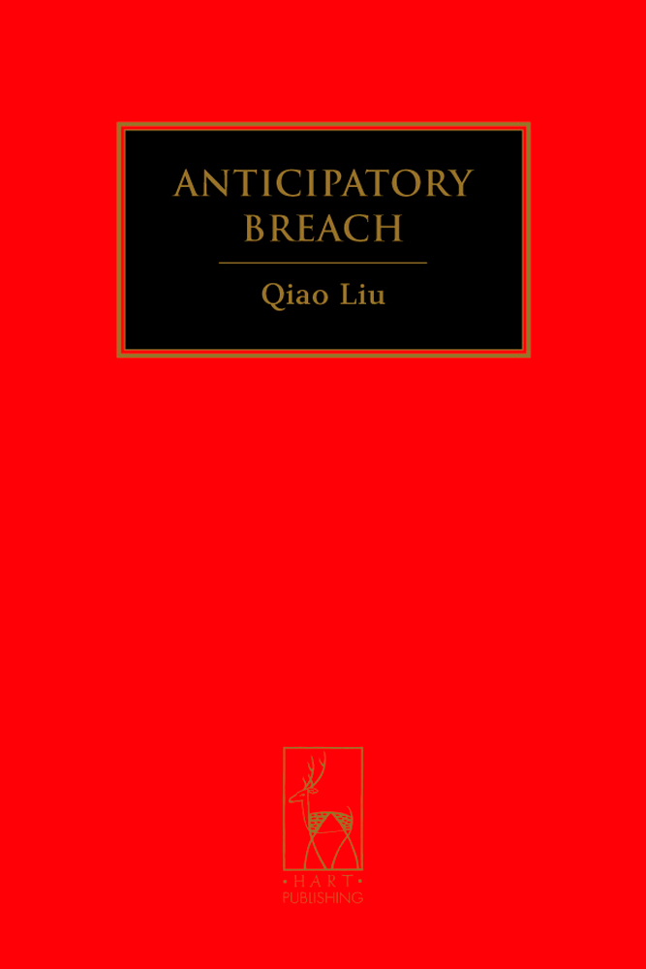
Anticipatory Breach

Qiao Liu

This work examines in detail the English doctrine of anticipatory breach, a hugely important subject in terms of both contract theory and commercial practice. It fills a significant gap in the existing literature with a comprehensive, systematic and in-depth treatment of the subject. The book not only restates the doctrine of anticipatory breach but also rejuvenates it, developing the proposition that the doctrine is essentially a mechanism for sanctioning present contractual remedies for future breaches. This proposition is developed in four parts consisting of nine chapters, which cover between them various aspects of the doctrine of anticipatory breach: historical genesis, theoretical characterisations, terminology, the constitution of an anticipatory breach, the defence of anticipated breach, the principle of election, the peculiarities of a right to claim damages, the assessment of damages, the victim's ability to continue with its performance and to claim the contract price when it is due, etc. Above all the book presents a carefully engineered critical review of the doctrine of anticipatory breach as it stands, challenging the misconceptions with which it was historically associated, the obscurity and precariousness of its theoretical foundation and the resulting inconsistency and inflexibility in its application. Instead, the author argues for a reformulation which follows a more rational, coherent and refined theoretical framework. This book is written in clear, straightforward language, and will appeal to academics, practitioners and law students alike.

Please click here for the table of contents (as a PDF file)
http://www.hartpub.co.uk/pdf/1849461120.pdf

The Author
Dr Qiao Liu is a senior lecturer teaching and researching in contract, commercial law and comparative Chinese law at the University of Queensland in Australia. He is also an Adjunct Professor of Comparative Law at the Xi'an Jiaotong University in China.

Jan 2011 242pp Hbk 9781849461122 £55 / €71.50 / US$110 / CDN $110
DISCOUNT PRICE: £44 / €57 / US$88 / CDN$88

___________________________________________________________________________
As a member of the Obligations Discussion Group listserv Hart Publishing is delighted to offer you 20% discount.

Order Online
If you would like to order this title you can do so through the Hart Publishing website.
http://www.hartpub.co.uk/books/details.asp?isbn=9781849461122

To receive the discount please mention ref: ‘ODG’ in the special instructions field. Please note that the discount will not be shown on your order but will be applied when your order is processed.

